Seeed Studio LoRa-E5 Mini GPIO Pin Mapping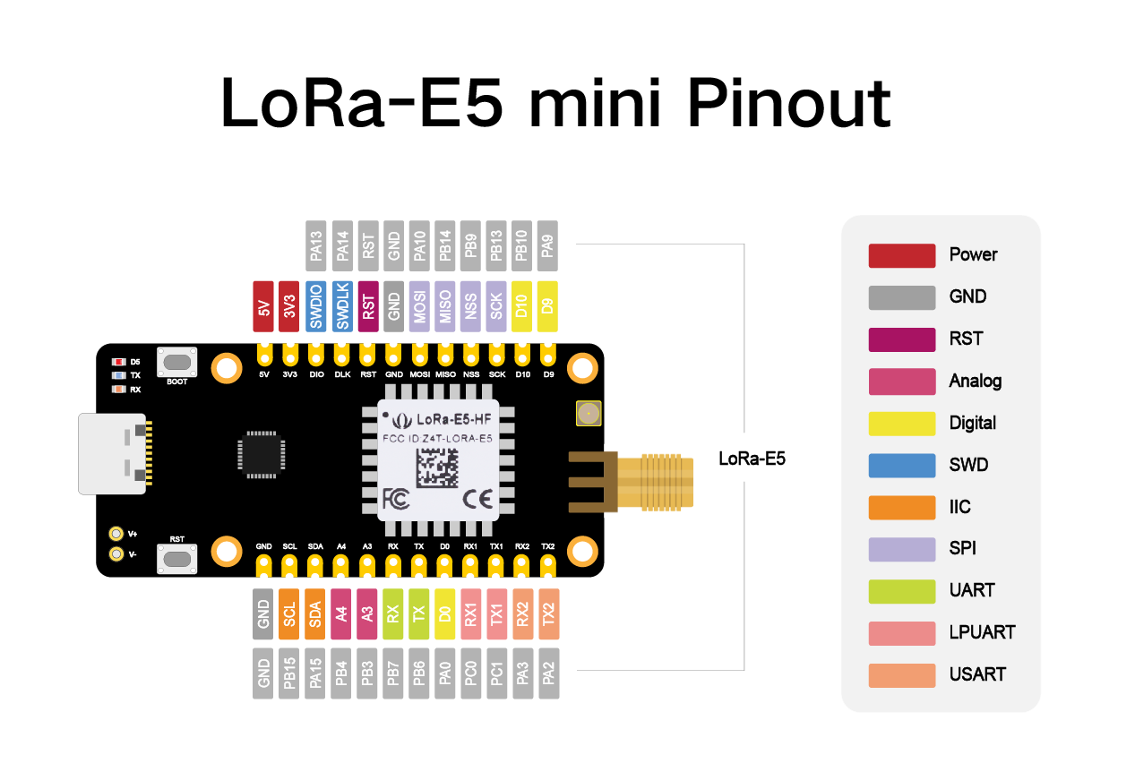

|  |  |  |  |  |  |  |  |  |  |  |
| --- | --- | --- | --- | --- | --- | --- | --- | --- | --- | --- |
| **Pin** | **Pin #** | **HAL GPIO Pin** |  | **Pin** | **Pin #** | **HAL GPIO Pin** |  | **Pin** | **Pin #** | **HAL GPIO Pin** |
| PA0 | 18 | GPIO_PIN_0 |  | PB1 | 33 | GPIO_PIN_1 |  | PC2 | 43 | GPIO_PIN_2 |
| PA1 | 19 | GPIO_PIN_1 |  | PB2 | 34 | GPIO_PIN_2 |  | PC3 | 44 | GPIO_PIN_3 |
| PA2 | 20 | GPIO_PIN_2 |  | PB3 | 3 | GPIO_PIN_3 |  | PC4 | 45 | GPIO_PIN_4 |
| PA3 | 21 | GPIO_PIN_3 |  | PB4 | 4 | GPIO_PIN_4 |  | PC5 | 46 | GPIO_PIN_5 |
| PA4 | 22 | GPIO_PIN_4 |  | PB5 | 5 | GPIO_PIN_5 |  | PC6 | 47 | GPIO_PIN_6 |
| PA5 | 23 | GPIO_PIN_5 |  | PB6 | 6 | GPIO_PIN_6 |  | PC7 | 48 | GPIO_PIN_7 |
| PA6 | 24 | GPIO_PIN_6 |  | PB7 | 7 | GPIO_PIN_7 |  | PC8 | 49 | GPIO_PIN_8 |
| PA7 | 25 | GPIO_PIN_7 |  | PB8 | 8 | GPIO_PIN_8 |  | PC9 | 50 | GPIO_PIN_9 |
| PA8 | 26 | GPIO_PIN_8 |  | PB9 | 9 | GPIO_PIN_9 |  | PC10 | 51 | GPIO_PIN_10 |
| PA9 | 11 | GPIO_PIN_9 |  | PB10 | 35 | GPIO_PIN_10 |  | PC11 | 52 | GPIO_PIN_11 |
| PA10 | 12 | GPIO_PIN_10 |  | PB11 | 36 | GPIO_PIN_11 |  | PC12 | 53 | GPIO_PIN_12 |
| PA11 | 13 | GPIO_PIN_11 |  | PB12 | 37 | GPIO_PIN_12 |  | PC13 | 2 | GPIO_PIN_13 |
| PA12 | 14 | GPIO_PIN_12 |  | PB13 | 38 | GPIO_PIN_13 |  | PC14 | 16 | GPIO_PIN_14 |
| PA13 | 29 | GPIO_PIN_13 |  | PB14 | 39 | GPIO_PIN_14 |  | PC15 | 17 | GPIO_PIN_15 |
| PA14 | 30 | GPIO_PIN_14 |  | PB15 | 40 | GPIO_PIN_15 |  | PD0 | 54 | GPIO_PIN_0 |
| PA15 | 31 | GPIO_PIN_15 |  | PC0 | 41 | GPIO_PIN_0 |  | PD1 | 55 | GPIO_PIN_1 |
| PB0 | 32 | GPIO_PIN_0 |  | PC1 | 42 | GPIO_PIN_1 |  |  |  |  |